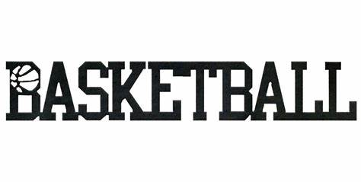

Please read over the packet, as it describes a particular sport or physical activity, relates its history, rules, playing techniques, and scoring. You will then find questions that relates to the sport, that will check your understanding and appreciation of the sport or physical activity. Please type up your responses to the questions, and then email them to your school specific PE teacher.

INTRODUCTION
Basketball is an extremely popular sport. More people watch basketball than any other sport in the US. It is played in driveways, parking lots, back yards, streets, high schools, colleges and professional arenas.
Basketball’s popularity is not just confined to the US. The game is also enjoyed internationally, with rules available in thirty languages. Basketball is also included among the Olympic sports.

HISTORY
In 1891, a PE instructor at a YMCA Training School in Massachusetts invented basketball as an indoor activity for boys. The game began with 2 peach baskets tied to balconies and a soccer ball used to shoot baskets. Two years later, two college teams began to play basketball. Is has continued to gain popularity ever since.
The National Basketball Association (NBA) is the largest professional sports league. It was created when the Basketball Association of America and the National Basketball League merges in 1949. The majority of professional players are recruited by the NBA from college teams.

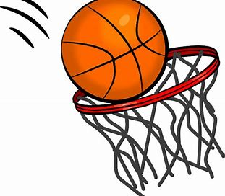
HOW THE GAME IS PLAYED
RULES
The game of basketball is fairly easy to understand. Players try to present their opponents from scoring while each team tries to get the ball through the basket that the other team is defending. Although the game is not difficult to understand, a tremendous amount if mental and physical endurance and skill is required from the five players on each team.
A basketball team typically consists of a center, two forwards and two guards. The forwards are positioned near the opposing team’s basket so they can ready for shooting and rebounding. The center is located near the basket or near the free-throw line so that they can be ready to contest shots and to rebound. Guards normally dribble the ball down the court to start offensive play.
The game begins with a jump ball. The referee tosses the ball into the air. As it comes down, one player from each team jumps up in an attempt to tap the ball to their teammate. Once the ball is in play, team members dribble the ball in order to get closer to their basketball or pass it to a teammate. “Dribbling” the ball means bouncing it on the floor repeatedly with one hand. “Passing” means to throw the ball to a teammate. Passing is vital to scoring plays. In fact, most professional consider good passing to be almost as important as accurate shooting.
When the ball is put into the basket, it is called a ‘field goal’ and two points are awarded to the team that scores. If the shot was taken past the three-point linem then three points are earned. The NBA instituted a new distance of 23’ 9’’ from the basket for the 3-point line. A “free throw” means taking a shot from behind the free-throw line, with no interference from the opposing team. If a player has been fouled by an opponent, the fouled player gets to shoot a free throw. If the free throw goes into the basket, the teams gets one point.
There are two types of fouls in basketball-personal fouls and technical fouls:
A personal foul means that a player holds, pushes or trips an opponent while going after the ball.
A technical foul may occur when the game is delayed, too many time-outs are taken, players or coaches leave or enter the court illegally or participate in misbehavior such as disrespect towards the players or referee.
A team may lose possession of the ball for “traveling.” Traveling occurs when a player runs or walks with the ball, and does not dribble. Double dribbling (bouncing the ball with both hands or stopping dribbling, then starting again) can also cause a team to lose possession of the ball.

DEFENSE AND OFFENSE
Professional basketball teams play four 12-minute quarters. College level play is two 20-minute halves, and high school basketball (depending on the State) is four 8-minute quarters. In the case of a tie game, teams will play overtime.
NBA teams play 5-minute overtimes.

DEFENSE
The zone and player-to-player (often called man-to-man) systems are two
defensive techniques. The zone uses each player as a guard, protecting a specific zone near the basket that their team is defending. Guarding the ball is more important than any particular player in this type of defense.

In the player-to-player (man-to-man) system, the opposite is true. Each player guards a certain player from the opposing team in order to keep them from scoring.

OFFENSE
The fast-break offensive style offers fast movement from one part of the court to another and a chance for scoring. It is characterized by fast, quick passes down the court and using more players on the attack than the opposition has for their defense.
Slower, more deliberate play characterizes the slow-break style. This technique calls for more thoughtful action; players maneuver carefully in order to shoot in this type of offense.

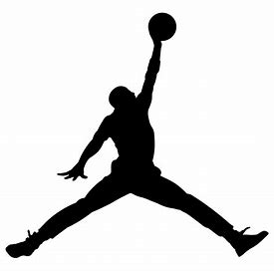

PLAYING TECHNIQUES
TYPES OF SHOTS
One-hand shot: A shot executed with both hands holding the ball initially. The ball is then pushed into the basket with one hand.
Hook shot: The ball is thrown toward the hoop over one shoulder. The center and forwards on a team will find this type of shot very valuable.
Two-handed shot: A shot usually made when a player is not very close to the basket. The ball is thrown with two hands, this type of shot tends to be much more accurate.
Jump shot: A shot in which the player shoots the ball into the basket at the top of the jump.
Lay-up: A shot in which a basket is attempted from under or on the side of the net; generally considered one of the easier shots.
Tip-in: A shot in which the ball is tapped back into the basket as it rebounds from the backboard.
Free-throw: A shot in which a player who has been fouled will shoot from behind the free-throw line.

BASIC PASSES
Two-handed chest pass: A pass used for short, fast passing of distances up to twenty feet.
Two-handed overhead pass: A popular pass that can be used from anywhere on the court, especially good for closely guarded players.
One-handed overhead pass: A pass used as a long pass from any position on the court. Like all one-handed passes, this move takes more time to perform and will require more control.
Bounce pass: The pass is used when two players are relatively close to each other. The ball usually bounces once before being caught by the other player.
One-hand underhand pass: An effective move when the passer is moving at fast speeds; difficult to perform and should only be used when there aren’t any alternative passing exists.

EQUIPMENT AND CLOTHING
A basketball is about two and a half feet in circumference and weighs 22 ounces. The baskets are made of a metal rind with an inside diameter of 18 inches. Netting or webbing hangs from the rind. Two baskets, one at each end of the court, hang 10 feet above the floor. The standard basketball court measures about 50 feet by 94 feet.
Clothing typically is loose-fitting and designed for freedom of movement. Basketball shoes are typically designed to withstand pounding on the floor in jumps and other movements, as well as to brace the feet and ankles during lateral movements.
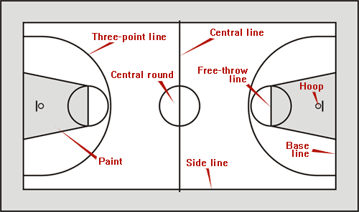

BASKETBALL NEWS AND CURRENT EVENTS
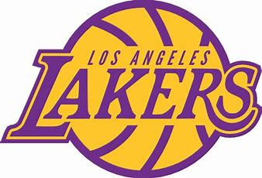
Kobe Bryant (August 23, 1978 – January 26, 2020) was an American professional basketball player. As a shooting guard, Bryant entered the National Basketball Association (NBA) directly from high school, and played his entire 20-season professional career in the league with the Los Angeles Lakers. Bryant won many accolades: five NBA championships, 18-time All-Star, 15-time member of the All-NBA Team, 12-time member of the All-Defensive Team, 2008 NBA Most Valuable Player (MVP), two-time NBA Finals MVP winner. Widely regarded as one of the greatest players of all time, he led the NBA in scoring during two seasons, ranks fourth on the league's all-time regular season scoring and all-time postseason scoring lists.

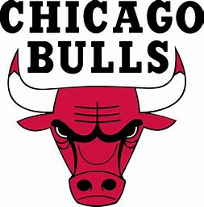
Michael Jeffrey Jordan (born February 17, 1963), also known by his initials MJ, is an American former professional basketball player and the principal owner of the Charlotte Hornets of the National Basketball Association (NBA). He played 15 seasons in the NBA, winning six championships with the Chicago Bulls. His biography on the official NBA website states: "By acclamation, Michael Jordan is the greatest basketball player of all time." He was one of the most effectively marketed athletes of his generation and was considered instrumental in popularizing the NBA around the world in the 1980s and 1990s.

2019 NBA Champions: Toronto Raptors
2019 NCAA Champions: Virginia Cavaliers
2019 WNBA Champions: Washington Mystics
2016 Men’s Olympic Gold Medal Winners: USA

NAME_________________________
DATE__________________________
Classroom Teacher________________

Please answer the following questions that will help you to have a greater appreciation and understanding of the sport of basketball. Once finished please email your responses to your specific PE teacher. Please try and write in complete sentences.
- What are some of the physical benefits of playing basketball?

- True or False: More people watch basketball than any other sport in the United States.

- Can you explain the objective in a game of basketball?

- How many players are needed for each team? What are the positions?

- What does a field goal mean? And how many points is it worth?

- Name 3 types of shots.

- Name 3 passes.

- Name two defensive techniques that are used.

- How high is a basketball hoop?

- Research a NBA team, and list 5 facts about them. (Key players, coaches, important wins, etc)

